**9.1**

**9_1**

Hello Khae

Hi Aanya. How are you?

I’m good. How are you?

I’m good. **I want to go out this weekend**. **Do you want to get breakfast with me on Saturday morning?** /ˈwiːk.end/

**Tomorrow morning?** **Can I tell you later this afternoon?**

Yes. It’s a new restaurant

**What’s it name?**

The restaurant’s name is Happy Food

**Are they open for lunch or dinner?**

**I can call the restaurant tonight**

**Is the food good?**

This is look good to you

Oh yes. It’s that

Khae wants to get breakfast on Saturday

Aanya wants to tell Khae something later this afternoon

**What is Happy Food?** 🡪 A new restaurant

Khae looks at a picture of food

It is now 10 A.M on Friday. Max is at work today

He wants to call his sister this afternoon

He wants to watch TV tonight

He wants to play basketball tomorrow moring

He wants to go out with his friends tomorrow night

He want to get breakfast with his sister on Sunday morning

He wants to play fooball on Sunday afternoon

Hi. **How are you today?**

I’m good. **How are you?**

I’m good. **Do you want to go out this weekend?**

Yes! I want to go out on saturday

Great. **Do you want to have lunch with me tomorrow?**

Lunch? ...**Can I tell you later this afternoon?**

Yes. I want to eat at Jim’s restaurant

Jim’s restaurant? Okay

**Are they open for luch tomorrow?**

I don’t know. I can call the restaurant later today

The food is really good. Here is a picture

It looks good!

A: **Do you want to get dinner with me tonight?**

B: Yes. Meet me at 9.PM

I can call you later this afternoon

A: **When can we get breakfast?**

B: On Sunday morning at 9 A.m

I want to play basketball this weekend

A: I’m hungry. **Do you want to get lunch?**

B: I can’t today. **How about tomorrow?**

A: **Do you want to go to movie?**

B: Not today, but I can go tomorrow.

**9_2**

**What's that?**

There my draws

Your drawing. **Are you designer?**

No. I don't draw for work. It's my hobby

Oh. Cool. **Can I see your drawing?**

Okay

**What do you draw?**

I draw animals

**What animals do you draw?**

This is a horse

Woa

This is a rabbit

Good drawing!

This is a sheep

That's a fish

You're right. It's a fish

And that's a bird

Yes. It's a duck. A duck is a bird

Duck they are delicious for dinner

What is the next animal

That's Todd. That's great.**Is he animal?**

People are animal. It's your

Thank you Aanya

Excuse me ladies

Hi Macro

Hi Aanya, Khae

How are you?

I'm good. One o'clock. **Do you want to eat luch with me?**

yes. We do

Great. Let's go

**What do you draw?**

I draw animals

**What animals do you draw?**

I draw dogs, cats and birds

**Can I see your drawing?**

Okay. This is a dog

Good drawing

Thanks. And this is a cat

Woa. **what is the next animal?**

It's a bird

That's a duck.

Yes. A duck is a bird

They are delicious

Yes, They are!

It’s a sheep.

**What is this?**

A bird.

That’s a fish.

**What are they?**

A person and a horse.

That’s a duck.

**What do you draw?**

Cats

**9_3**

**Do you want some chicken?**

Yes, please

**No. I’d like some soup**

**I like salad**. **Do you want some salad?**

Yes, please

**Yes. I’d like some salad**

**Do you want some salad dressing?** /ˈsæl.əd/

No

**Yes. I’d like some salad dressing.** Thank you

You’re welcome. **Oh. There’s is bread**. **Who wants some bread?**

No bread for me

**I’d like some bread**

Marco, Khae, and Aanya are at luch

What doese Marco do?

* He serves chicken

Marco, Kae, and Aanya all want salad

Marco and Aanya want salad dressing

Khae wants bread

Do you want some salad dressing?

I’d like a sandwich, please

I wnat two eaggs

We’d like some cake

Oh, there is chicken

Beans are good

I like coffee

I’d like some pizza

Do you want some pasta?

Yes, please!

Okay, do you want some chicken?

No chicken for me

Tomato soup?

Oh, good! I like tomato soup

Do you want some soup?

Yes. I’d like some soup. Thanks

Who wants some salad, Aanya?

No, thanks

Okay, do you want some cake?

Yes, I’d like some cake! Thank you

You’re welcome. Cake is delicious

Yes, it is!

Do you want some orange juice?

I like pizza

I’d like some salad dressing

I’d like a chicken sandwich for luch

Oh, there is pasta! I like pasta!

Do you want some milk in your coffee?

Hello, Joseph! How are you? Can you have luch with me later this afternoon? I can meet you in two hours

I fine, thank you. Sorry, I can’t have luch with you today. But I can meet you tomorrow for breakfast

That’s great! Can I call you tonight?

I eat breakfast in the morning

What time does the restaurant open this afternoon? It opens at 1:00 o’clock today

Do you want to see a movies this weekend? I can go with you on Saturday night

Keiki and Jun want some orange juice to drink with luch

Julio wants some soup for luch

I’d like some bread with me dinner

Bart gets a sandwich for luch

Do you want coffee?

* Yes, please and I want some milk with my coffee

Do you want a pizza and salad for dinner?

* Yes, please. I’d like that

I’d like some chicken for dinner tomorrow

There’s salad dressing on the table

I like toast for breakfast on the weekends

There is some bread in the bag.

What’s in the bag?

* There is some water in the bag

Mama’s Restaurant has good Italian food.

* Hmm... I’d like an Italian sandwich for dinner

Todd: Whose drawing is this? It isn't funny!…Hey, Aanya! Is this your drawing?

Aanya: Well…that's a drawing of you. I don't draw people. I draw rabbits, cats, birds…

Todd: Oh! I need drawings of an animal for an ad. I want to see your drawings.

Aanya: Um…OK. Here.

Todd: What's this thing? It's in water. Is it a fish?

Aanya: No! It's a bird in water. It's a duck!

Todd: Oh. And this big animal…is it a sheep?

Aanya: No! Can you see the boy on it? It's a horse!

Todd: What??...Sorry, but your drawings are not good. You can't draw for my ad.

Aanya: OK. Fine.

Todd: …Hey!! Your drawing has a boy in it! Boys are people! You DO draw people! So this drawing of me…is it…?

Aanya: Sorry, it's time for lunch! See you later, Todd!

1 Do you want to go to a restaurant on Friday night ?

2 I want to get breakfast tomorrow morning.

3 Can you come later this afternoon?

4 Do you want to play basketball this weekend?

5 How are you today?

6 I can call you on Saturday afternoon

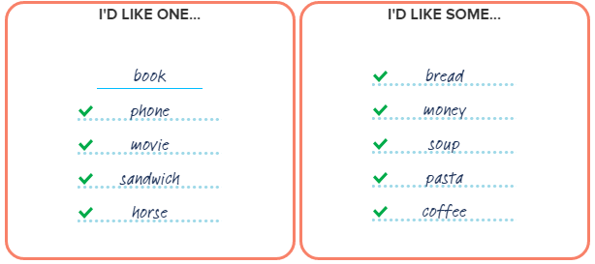

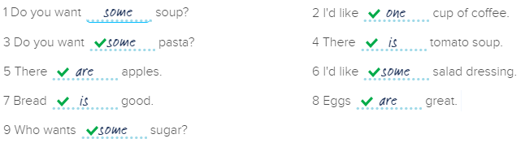

Marco: I want to watch a movie this weekend.

Khae: Cool! I like movies.

Marco: Oh! Can you go to a movie with me on Friday night?

Khae: Uh...I don't know. Can I tell you later this afternoon?

Marco: OK. Later is fine....Can you eat lunch with me on Saturday?

Khae: Yes, I can. Can we eat at Grove Restaurant?

Marco: Yes. I like Grove Restaurant. They have good food.

1 Todd likes: soup and salad

2 Todd wants today: tomato soup

3 Todd can eat today: salad

4 Aanya likes: chicken

5 Aanya wants today: chicken sandwich

Allie: I want a cat.

Jeff: Wow! A big cat or a small cat?

Allie: A big cat. I want to find a cat tomorrow afternoon. There’s a store for cats. Can you go to the store with me?

Jeff: Tomorrow afternoon? I can’t go tomorrow afternoon.

Allie: Oh. Can you go Thursday evening?

Jeff: No. I can go Friday evening. We can get some pizza too. OK?

Allie: OK! Friday evening is good!…But I don’t like pizza.

Jeff: Do you like pasta?

Allie: Yes. Pasta is good.

Jeff: Great! I like pasta too.

Allie: Hey, you can get a cat on Friday too!

Jeff: No!! I don’t like cats. I like birds!

1 Allie wants a big cat.

2 Allie want to find a cat with Jeff.

3 Allie wants to go to a store for cats.

4 Allie wants to go tomorrow afternoon.

5 Jeff wants to go Friday evening.

6 Allie likes pasta.

7 Jeff doesn't like cats but he likes birds.